Serverless api-resource

1. Add the below code in the ui dashboard

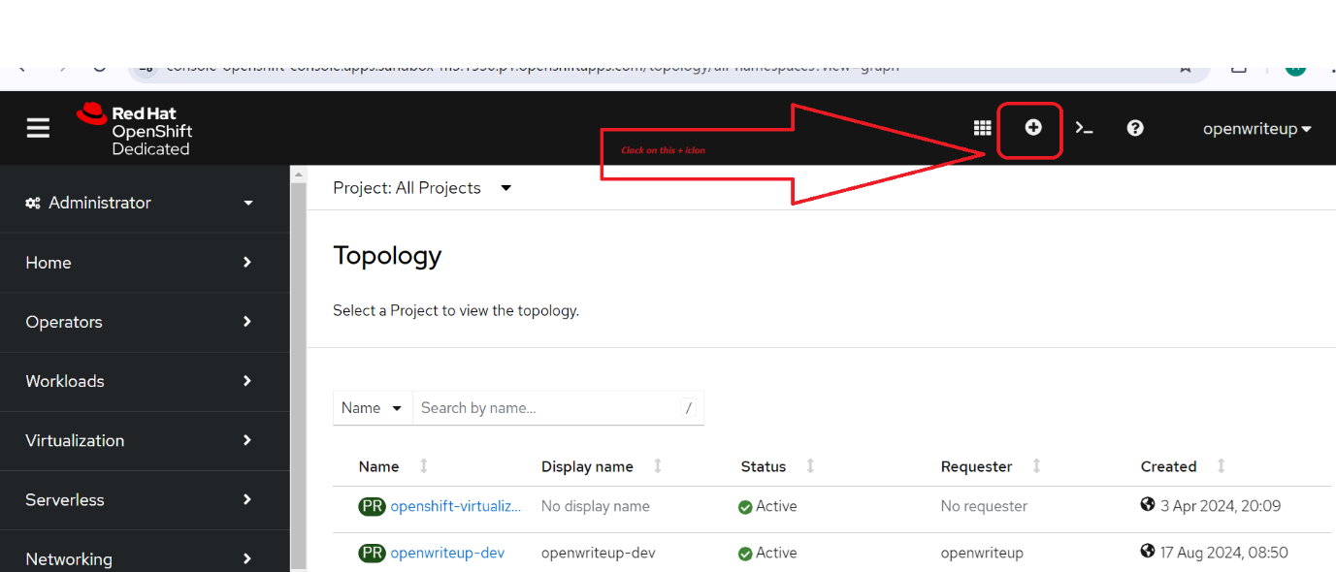

1. Copy the below yaml file

apiVersion: v1

kind: ServiceAccount

metadata:

name: events-sa

---

apiVersion: rbac.authorization.k8s.io/v1

kind: Role

metadata:

name: event-watcher

rules:

- apiGroups:

- ""

resources:

- events

verbs:

- get

- list

- watch

---

apiVersion: rbac.authorization.k8s.io/v1

kind: RoleBinding

metadata:

name: k8s-ra-event-watcher

roleRef:

apiGroup: rbac.authorization.k8s.io

kind: Role

name: event-watcher

subjects:

- kind: ServiceAccount

name: events-sa

1. Make sure you have selected your project and click on create

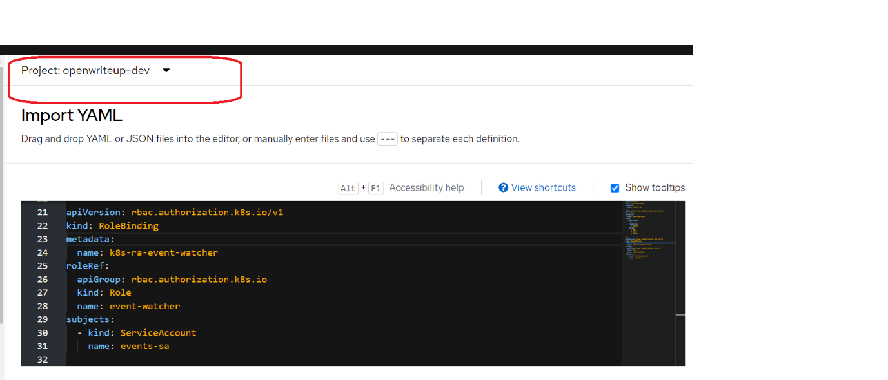

1. All the resources are provisioned

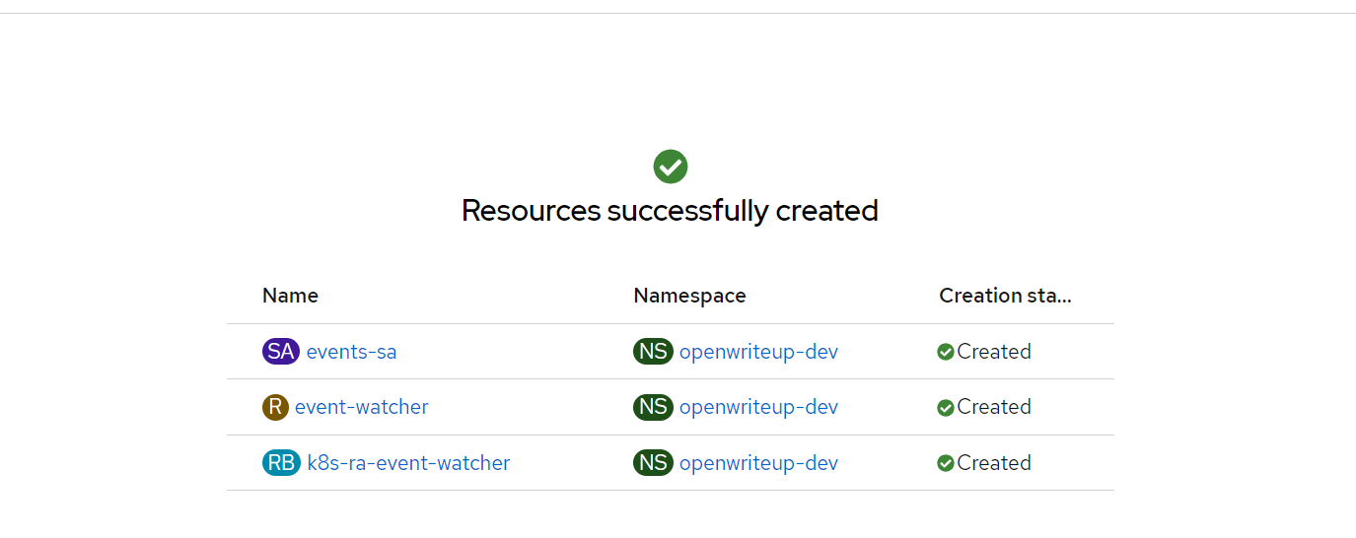

5) In the **Developer** perspective, navigate to **+Add** → **Event Source**. The **Event Sources** page is displayed.

1. Optional: If you have multiple providers for your event sources, select the required provider from the **Providers** list to filter the available event sources from the provider.
2. Select **ApiServerSource** and then click **Create Event Source**. The **Create Event Source** page is displayed.

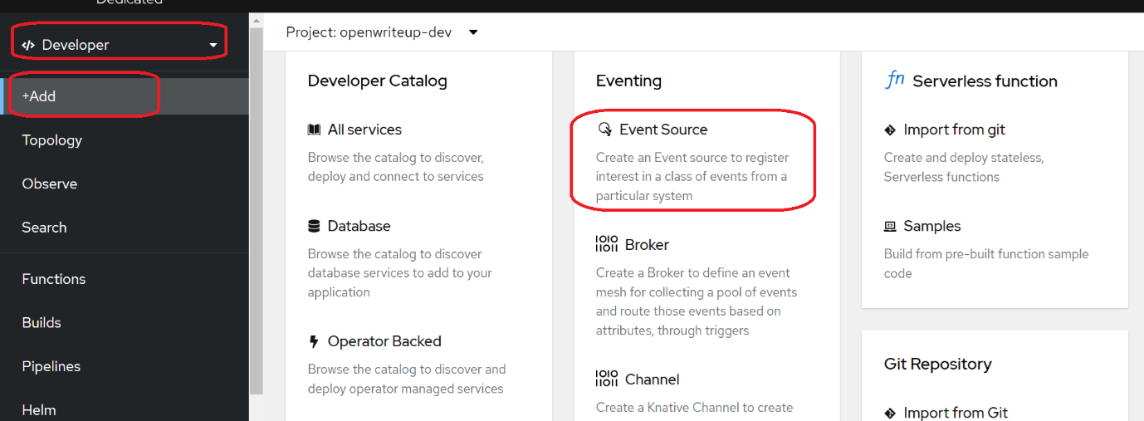

1. Configure the **ApiServerSource** settings by using the **Form view** or **YAML view**:

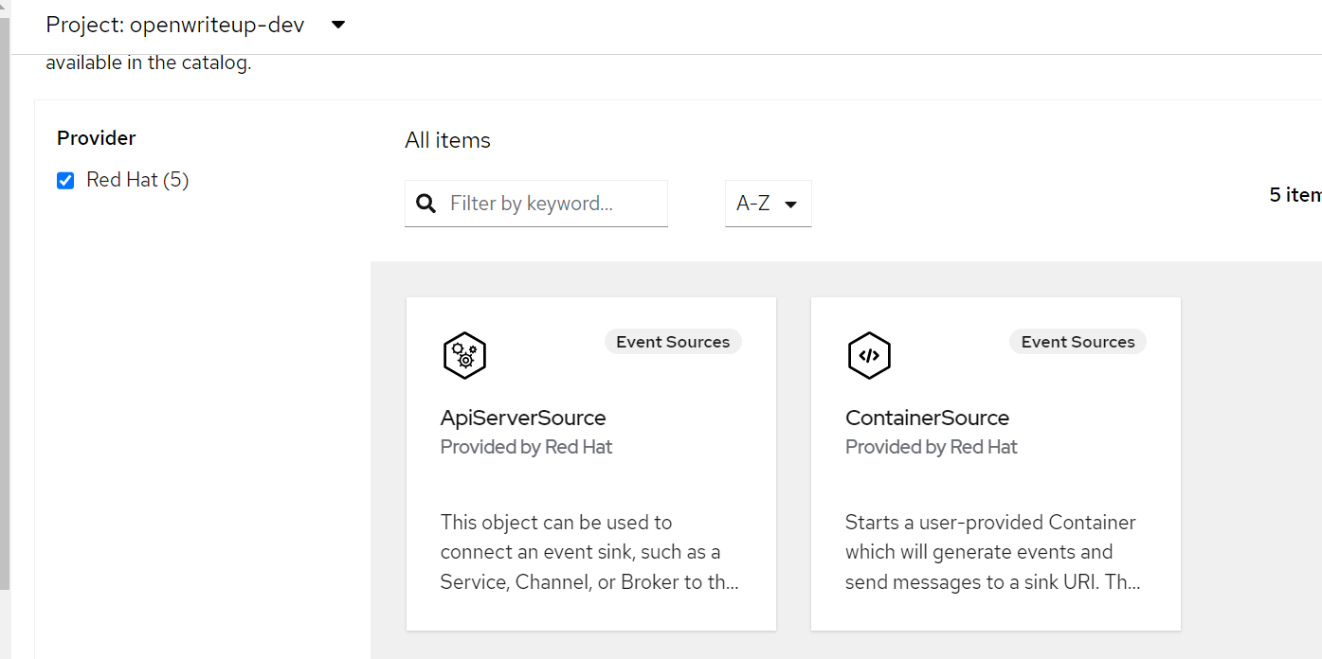

|  |  |
| --- | --- |
|  | You can switch between the **Form view** and **YAML view**. The data is persisted when switching between the views. |

* 1. Enter v1 as the **APIVERSION** and Event as the **KIND**.[v1, Event]
  2. Select the **Service Account Name** for the service account that you created.[event-sa]

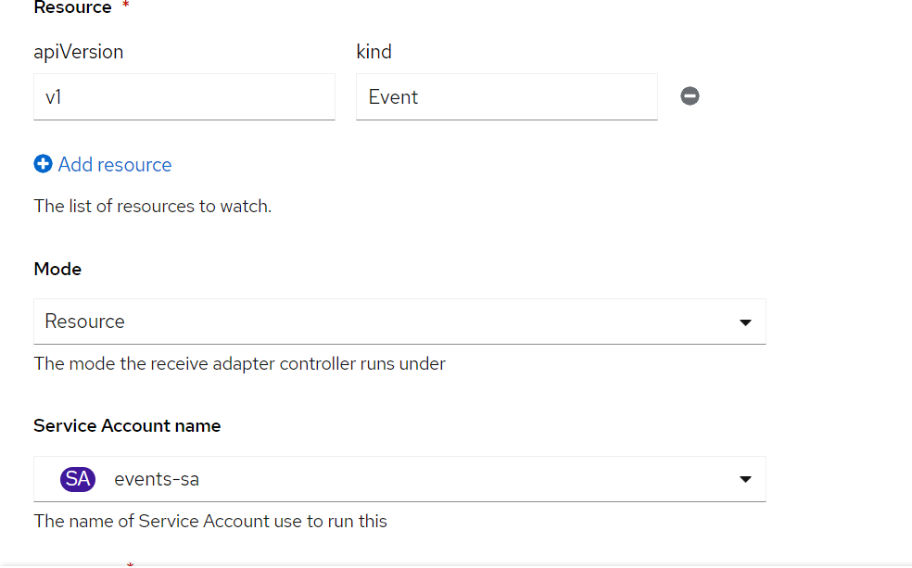

* 1. In the **Target** section, select your event sink. This can be either a **Resource** or a **URI**:
     1. Select **Resource** to use a channel, broker, or service as an event sink for the event source.
     2. Select **URI** to specify a Uniform Resource Identifier (URI) where the events are routed to: [**http://event-display.svc.cluster.local**](http://event-display.svc.cluster.local)

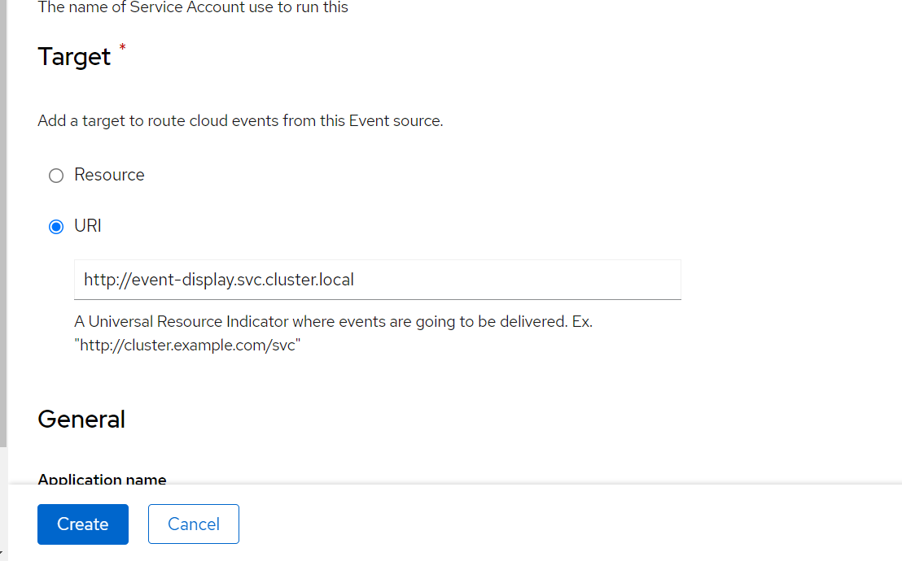

1. Click **Create**.